Alexander Mekovsky
Lab 02
2/15/2023
COSC 320 Enyue Lu
Lab Report: I have successfully completed all tasks for this lab. I have calculated the worst cases for both unsuccessful and successful runs. Based on what we know for the time complexity of binary search the worst case for binary search is O(log2(n)). After finishing the lab and incorporating binary search and double ended selection sort, the the result I gotten about the worst case finds:

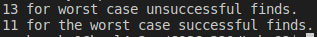

Based on my response, 13 does seem like a good estimate for the worst case of unsuccessful finds, as when calculating the time complexity of O(log2(10000)), you get this:
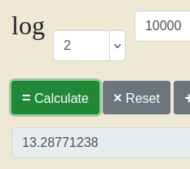

So yes, based on the calculations of both the program and the logarithmic calculator, 13 does seem like a good answer for the worst case of unsuccessful finds.

Overall including class time and time outside of class it took me about three hours to finish the lab. I have had several problems while completing the program, the most prevalent being an infinite loop while in the binary search function. To fix this, I corrected my order of operations and tweaked my variables to avoid any improper errors. I had no issues implementing the double ended selection sort, so that part went smoothly.

